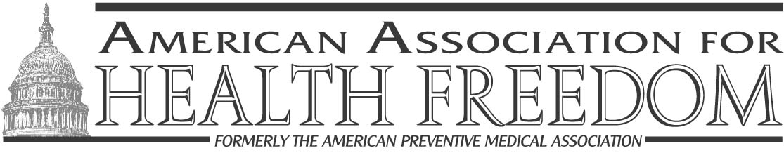

Dear Friend:

Your access to dietary supplements is threatened.

The “Dietary Supplement Safety Act of 2003,” introduced by Senator Durbin (D-IL) is a very serious threat to the supplement industry and your individual health freedom. Despite its name, this bill would allow no more consumer protection than current law provides. It will, however, grant the Food and Drug Administration (FDA) more authority and directly violate your health freedom. Under this ruling, the FDA could pull any dietary supplement off the market based on a single reported consumer “adverse experience”. Call your Senator today urging him/her to oppose S.722. Unless you don’t mind the FDA controlling which supplements you purchase.

Do you want the FDA to have more control?

Without opposition, this bill can easily be added to existing Senate legislation at any time, posing a serious threat to the Dietary Supplement Health and Education Act (DSHEA) and your freedom of choice in health care. Senator Durbin indicated that he is ready to offer his bill as an amendment to the Agriculture/FDA spending bill when the full Senate considers it. And Senators Clinton (D-NY) and Feinstein (D-CA) have signed on as cosponsors. This is serious.

Oppose this Legislation! Take action now!

The FDA currently has all the necessary enforcement power to protect the public from unsafe or illegal dietary supplements. They currently have the authority to regulate the types of ingredients that can be used in dietary supplements, the potency and purity of those ingredients, and the claims that can be made on behalf of these products. This bill would subject nearly all vitamins, minerals, herbal products and other supplements to a level of scrutiny that is unwarranted, unnecessary and expensive. It completely undermines the primary goal of DSHEA to restrain the FDA’s historical abuse of discretionary authority over dietary supplements.

We need your help NOW to make a difference?

♦ Visit the American Association for Health Freedom’s Legislative Action Center by following the link http://www.capwiz.com/apma/home/ and call or write to your Senator, urging him/her to oppose S.722 today (a copy of the letter is on the back).

♦ Forward this information to everyone you know that is interested in protecting their health freedom and urge them to take action today.

♦ Contribute $25 - $10,000 to support AAHF’s lobbying efforts. Your contributions will be used not only to fund a Washington, D.C.-based lobbyist, but to capitalize on our grassroots support as well as build and work with the necessary coalitions for the most effectiveness.

Thank you for your immediate attention and action to help defeat this bill. Every letter written and every phone call helps. When we go to Capitol Hill and speak with the Senators and their staff, they always want to know what their constituents think … so be sure to tell them that you oppose S.722.
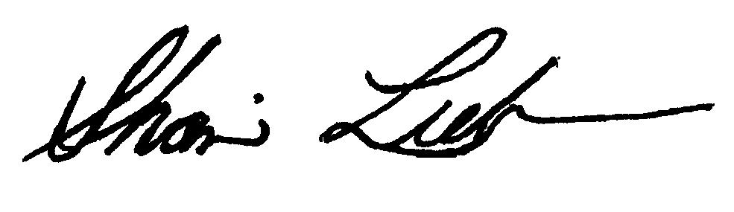
Sincerely,

Shari Lieberman, Ph.D., CNS, FACN
AAHF President
P.O. Box 458 ♦ Great Falls, VA 22066 ♦ 800-230-2762 ♦ www.healthfreedom.net

Office of Senator _______________
United States Senate
Washington, DC 20510
Fax ________________

Dear Senator ______________:

Please oppose any efforts by your fellow Senators to enact S.722, the “Dietary Supplement Safety Act of 2003” introduced by Senator Durbin.

The FDA should not have the authority to take away my dietary supplements and, once again, infringe upon my health freedom.

The FDA has already been given broad, legal authority to regulate all aspects of manufacturing, marketing and distributing dietary supplements. Rather than encouraging the FDA to start enforcing existing law, S.722 would grant the FDA new enforcement powers without any increase in the protections to consumers under the existing law. Despite its name, Senator Durbin’s Bill is not about consumer safety.

Under Senator Durbin’s Bill, the FDA would have enforcement powers that include expanded authority enabling them to remove from the market safe and healthful dietary supplements. This would completely undermine the primary goal of the Dietary Supplement Health and Education Act of 1994 (DSHEA) to restrain the FDA’s historical abuse of discretionary authority over dietary supplements. This is outrageous!

Even if just one report of an adverse experience occurring while taking a dietary supplement is received, even though it is not know to be causally related to the dietary supplement, the FDA will have the authority to start procedures ending the marketing of the ingredient under the Durbin Bill. All of these procedures are left entirely to the unbridled discretion and whim of the FDA.

I urge you to oppose this unnecessary legislation. Support the FDA in enforcing the existing law, but please don’t give them the authority to continually chip away at my health freedom.

I look forward to hearing back from you on your position.

Sincerely,

My Dietary Supplements are Too Important to Me!

Count on me! I’d like to contribute $________ (circle one - one time/monthly) to the American Association for Health Freedom’s efforts to fight the “Dietary Supplement Safety Act of 2003” and related legislation that infringes upon my health freedom.

I am unable to contribute financially, but am willing to help spread the word about the danger of the “Dietary Supplement Safety Act of 2003” (i.e. sending out emails to personal and professional contacts to generate more letters to Senators). Contact me.

Name __________________________________________________________________________________

Address _________________________________________________________________________________

City _________________________________ State __________________ Zip _________________________

Phone ____________________________________ Email _________________________________________

Signature __________________________________

Cash/Check

Credit Card (Visa, MasterCard, AmEx, Discover)

# __________________________________________________ Exp. date ______________________

To speak with someone personally about how you can help, please call 800-230-2762 and ask to speak with Tricia Fischer (tricia@healthfreedom.net).

Mail or Fax to:

American Association for Health Freedom
Attn: Oppose Durbin/S.722
P.O. Box 458
Great Falls, VA 22066

703-759-6711 fax

